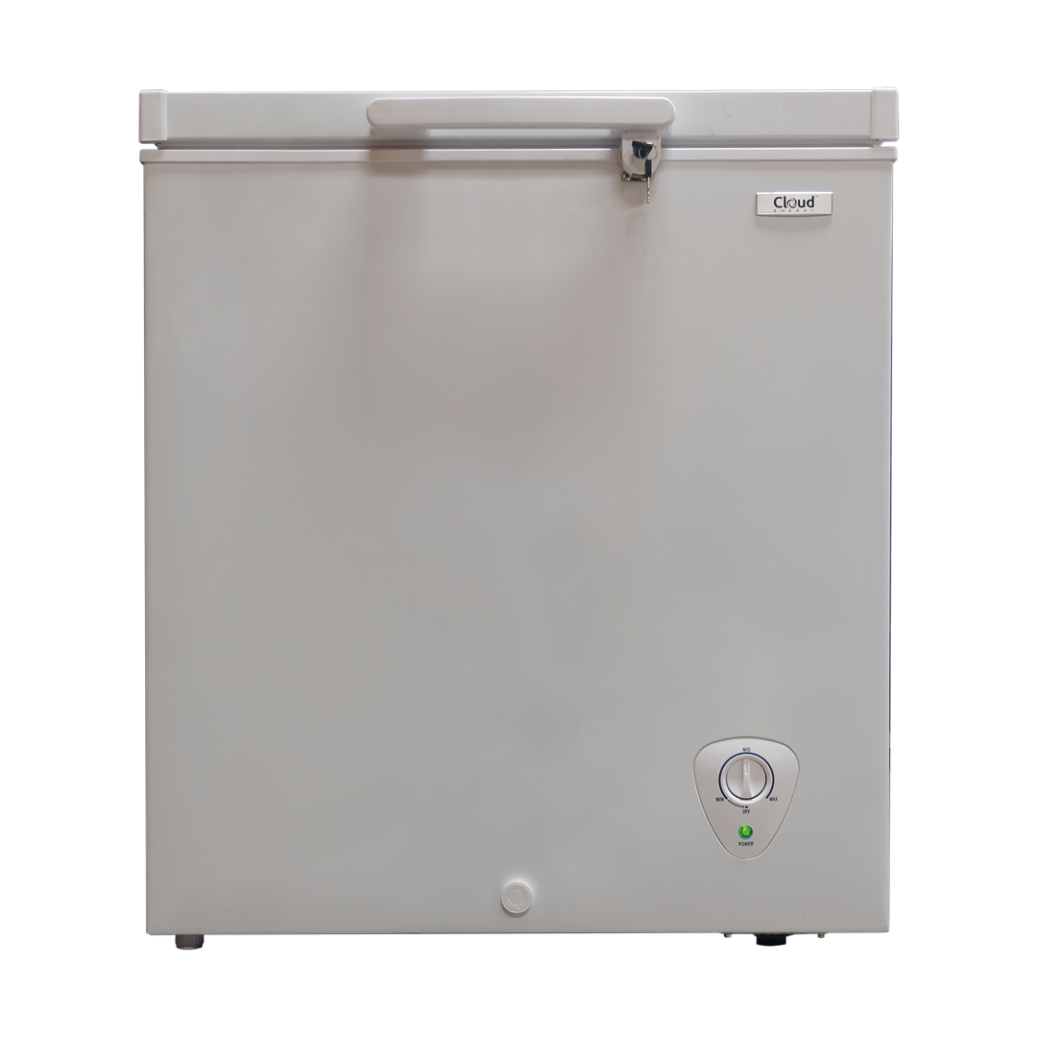
Product Description
Cloud Energy 150L Solar Freezer Energy Saving
Refrigerator runs on a single 75w module in most climates
12 or 24 VDC with low voltage disconnect for battery protection environmentally friendly CFC free refrigerant (R-134a)
Rugged scratch resistant galvanized steel exterior Easy to clean aluminium Interior light patented…
Weight: 30 Kg

